SafeWayz Mobile Application
SE 2XB3: Binding Theory to practice,
CAS Department, McMaster University
Version 1.0
March 9, 2020
Group #: G02

Group Members:
Aditya Sharma
Anando Zaman
Daniel Di Cesare
Jash Mehta
Zachary Ren

Revision Page:

By virtue of submitting this document we electronically sign and date that the work being submitted by all the individuals in the group is their exclusive work as a group and we consent to make available the application developed through [CS] or [SE]-2XB3 project, the reports, presentations, and assignments (not including my name and student number) for future teaching purposes.

Aditya Sharma:________________________________________________
Student Number: 400189221
Anando Zaman:__________________________________________________
Student Number:
Daniel Di Cesare:________________________ ___________________________
Student Number: 400179249
Jash Mehta:_______________________________ ____________________________
Student Number: 400185652
Zachary Ren:___________________________________________________________
Student Number:

Report Revision History:

Version | Primary Authors(s) | Description of version | Date completed
Draft Stage 1 | Anando Zaman,  Daniel Di Cesare | Initial draft with class diagram/description, executive summary, and Module USE relations complete | 04/04/2020
Draft Stage 2 | Anando Zaman | UML State Diagrams complete. MIS for DFS,BFS, Android Activities complete. Some progress on review of the design section. | 04/05/2020
Draft Stage 3 | Jash Mehta  Anando Zaman | Completed CrimeSorting, CrimeSearching MIS, and added information to the State Diagram and Implementation section. Changes to formatting of document.  Added Table of contents, glossary, and references. Cleaned up formatting. Added the problems encountered during the design stage and possible future revisions in the design review section. | 04/07/2020

Contribution Page:

Name | Role(s) | Contributions
Aditya Sharma | - Project Leader  - Tester  - Developer | - Cleaned and Merged entire data set  - Formatted entire data set from CSV to JSON  - Established plan for the entire project  - Implemented DFS Algorithm  - Created an additional modular testing file for DFS/BFS
Anando Zaman | - Researcher  - Technical lead  - Developer  - Tester/Validation | - Researched crime and street datasets  -BFS Implementation  - Testing of DFS/BFS  - Application development and integration(DFS and Dijkstra plotting, hashing, dynamic UI) + Maps API
Daniel Di Cesare | - Designer  - Developer  - Tester/Validation | - Dijkstra Implementation  - Testing of Dijkstra  - Integration/porting of eclipse-terminal code into Android Application + Maps API
Jash Mehta | - Designer  - Developer  - Tester/Validation | - Searching/Sorting Implementation  - Design and functionality of Application
Zachary Ren | - Developer | - Addition of weights to Dijkstra

*Comments clarify overlapping contributions, since this is what the outline says...

Executive Summary

SafeWayz is an application focused on providing safety-oriented navigation to its users in San Francisco. The application provides routes determined based off of previous crime data trends as well as relative distance. Using the previous crime data, a weighted graph is created to represent all the connecting streets and intersections within the city of San Francisco. Once each intersection is determined, a crime weighting is assigned based off of frequency and severity of crimes at that location. Currently, BFS, DFS, and Dijkstra’s algorithm can be run on the graph, with BFS and DFS connecting streets and Dijkstra’s connecting between intersections.

Once the route is determined, the passed intersections are sent through the Directions API from google. A path is returned which can be plotted on google maps natively within the application. Users also have the option to view crime weights for a specific street, and also the option to view a sorted list of intersections with the lowest crime ratings.

Table of Contents
Glossary………………………………………………………………………………………………...….6

Class Diagram/Description………………………………………………………………………………..7
UML diagram………………………………………………………………………………………7
High level Description …………………………………………………………………………..8-9

Module Description/Structure/USES…………………………………………………………………..10
GenerateHashtable……....………………………………………………………………………..10
DFS_ALLPATHS…………………..………………………………………………………....11-12
BFS_ALLPATHS……………………………....…………………………………………………13
CrimeSort……….…………………..…………………………………………………………15-16
CrimeSearch…………….……………………...…………………………………………………17
RunDijkstra……………....……………………………………………………………………….18
Dijkstra……………..……………………………………………………………....……………..19
MainActivity…………………………………………………………………...…………………20
Dijkstra_Activity…………………….…………………………………………..………………..21
DFS_Activity….…………………….…………………………………………..………………..22
CrimeFeature.….…………………….…………………………………………..………………..23
GMaps……...….…………………….…………………………………………..………………..24
Module USES Relation..…………….…………………………………………..………………..25

State Diagrams/Implementation………………………………………………………………………...26
HashTable…………………….……….…………………………………………………………..26
GraphTraversal.………....……...………..………………………………………………………..26
Dijkstra’s Paths…..……...……………....………………………………………………………..27 CrimeSort…...………………….…………..……………………………………………………...27
Android Activities.......………….…………..……………………………………………………...28
State Diagrams….........………….…………..……………………………………………………...29
Review/Evaluation……………………………………………………………………………………30-31
References………………………………………………………………………………………………...32

Glossary

App: An abbreviation for “application”. It is essentially a software product designed for mobile devices. [1].

API: An abbreviation for “Application Programming Interface”. It is a software product that contains definitions, protocols and written code that is frequently used to allow for modular programming [8].

BFS: An abbreviation for the shortest-path finding algorithm “Breadth-first Search”. This algorithm is generally used to find the shortest-route between two points. [7].

DFS: An abbreviation for the path-finding algorithm “Depth-First Search”. This algorithm is generally used to find any route between two points [10].

Efficient: This term is defined by the time and space complexity of all the algorithms that the software product is composed of. A software product is said to be efficient iff (defined below) the space/ time complexities are at a global minimum [9].

IFF: If and only if

JSON: An abbreviation for the word “JavaScript Object Notation”. This is a format that is used for storing data. It is similar to a hashmap/ hashtable [4].

Optimal Path: It is defined as the safest route between two locations specified by the user.

UI: An abbreviation for the word “User Interface” [3].

UX: An abbreviation for the word “User Experience” [11].

Weighting: Also termed a ‘cost’; impacts the viability of a point within a dataset [6].
Dataset: An organized collection of data [5].
Dijkstra’s Algorithm: Efficient solution for finding the shortest route between two points in a graph [2].

Class diagram and description

UML Diagram: (https://i.stack.imgur.com/2ajCN.gif)
Clearer Image found on (https://drive.google.com/file/d/107cKQsJVs7YnuSyPDJDqFavTE4OKNt7Z/view?usp=sharing)

Fig 1.1 Below: Application UML Diagram

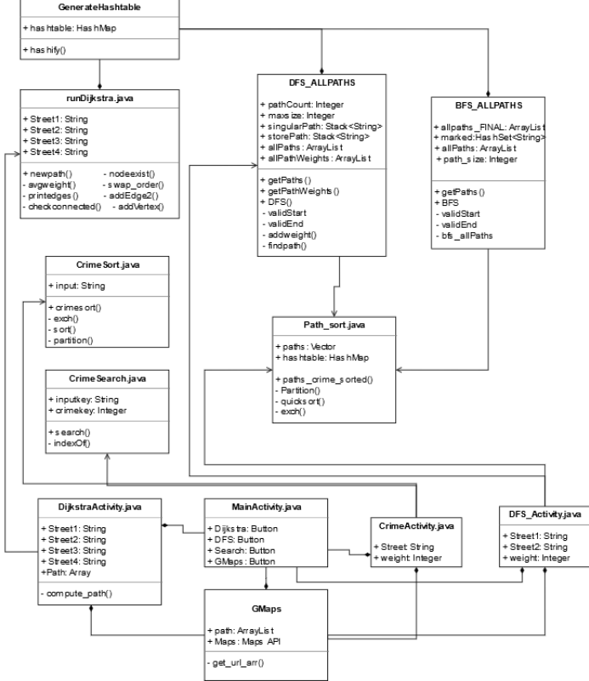

High level description
SafeWayz consists of many classes that are shown in the UML diagram above. The following is a brief description of the various components. This will include both syntax, semantics, relationships between modules, and design decisions

The modules are separated into the following 5 categories:
- Hashtable
- GraphTraversals
- Dijkstra's Paths
- CrimeSort
- Android Activities

The modules were designed by these five categories to preserve modularity and promote separation of concerns. This way, specific features and characteristics can be traced to the respective module to debug and analyze issues during the unit testing and debugging stage. It also makes development more efficient as developers can work in different folders rather than one large folder.

These five categories are labelled this way since the application consists of 4 main features:
- Generating the optimal least crime path (Dijkstras)
- Generating the least crime path with a specific number of streets(DFS, BFS, Sort, Search)
- Computing the street that makes an intersection with a given street and crime weighting(Crime Sort/Search)
- Plotting and navigating through the Android view

Below is a summary of the modules:

The Hashtable category consists of only the GenerateHashtable module. This module reads the WeightData.json file which represents the undirected graph in JSON format. The end behaviour of this module is to output a hashmap from the JSON data to be used throughout the rest of the application

The GraphTraversals category consists of 2 files which are DFS_ALLPATHS and BFS_ALLPATHS modules. This category is used for traversing through the graph and computing all possible paths from start to end street. Both have similar behaviour as they both compute the possible paths and save them into a 2D vector to be accessed later.

Dijkstra's Paths category consists of the modules needed for computing the least crime path via Dijkstra's Algorithm. It is separate from the GraphTraversal category as it is more complex compared to the simpler DFS and BFS algorithms. It also uses different file dependencies. For these reasons, it is logical to keep the components of this algorithm separate, so that it is easier to trace back problems specifically for this algorithm alone. This module takes the start and end street intersections in which it then returns a hashmap of the computed path.
The CrimeSort category consists of the various Search and Sorting algorithms needed in the CrimeFeature. Specifically, these files are CrimeSorting.java and CrimeSearch.java. This category also contains the path_sort module, which finds the least crime path from a sequence of all possible paths. If the least crime path cannot be computed, it returns a NullPointerException.

The Android Activities category is specific for use with Android studio. The files here consist of mainly the activity files that represent different pages of the application. The behaviour consists of the general UI flow such as interacting with the application. This can include moving between pages by clicking the buttons, or interacting with the Maps API to zoom in on the plotted path.

Module Description/Structure/USES
GenerateHashtable Module
GenerateHashtable()
Description:
Parses the JSON data into a hashtable to be used in Java. This hashtable will represent the undirected graph along with its data

USES
WeightedData.json generated from implement_weights.py

Syntax
Exported Constants:
None

Exported Types:
Hashmap of JSON data

Exported Access Programs

Routine name | In | Out | Exceptions | Description
Hashify | WeightedData.json | HashMap | NullPointer Exception | Outputs hashtable format of JSON data

Semantics

State Variables:
None

Access Routine Semantics

Hashify(JSON data): // This method reads the JSON graph and outputs it in the form of a hashmap
- Output: HashMap format of the data
- Exception: if file is not found or unparsable, NullPointerException is raised

DFS_ALLPATHS Module
DFS_ALLPATHs()
Description:
A class that computes all possible paths from a given start street and end street via DFS algorithm

USES
GenerateHashtable

Syntax
Exported Constants:
None

Exported Access Programs

Routine name | In | Out | Exceptions | Description
DFS_ALLPAThs | Integer | DFS_ALLPAThs | NullPointer Exception | Creates object of class
getPaths |  | ArrayList<Vector<String>> |  | Returns 2D arraylist of all paths
getPathWeights |  | ArrayList<ArrayList<Integer>> |  | Returns 2D arraylist of weights of the paths
DFS | String, String | None | NullPointer | Computes the paths and saves it to allpaths 2D ArrayList

Semantics

State Variables:
pathCount = Integer;
maxSize = Integer;
hashtable = generateHashtable.hashifiy("WeightedData.json");
singularPath = Stack <String>;
storePath = Stack <String>();
allPaths = ArrayList<Vector<String>>()
allPathWeights = ArrayList<ArrayList<Integer>>()

Access Routine Semantics

DFS_ALLPAThs(maximum_size): //constructor
- Output: new DFS_ALLPATh
- Exception: NullPointer if cannot create

getPaths(): //returns all the possible paths computed from the DFS algorithm in the form of a 2D list
- Output: this.allpaths

getPathWeights(): //gets an array full of crime weights for allpaths
- Output: this.allPathWeights

DFS(): //Executes the DFS algorithm to compute the paths and store them in the allpaths arraylist
- Transition: allpaths.add(this.storePath)

BFS_ALLPATHS Module
BFS_ALLPATHS()
Description:
A class that computes all possible paths from a given start street and end street via BFS algorithm

USES
GenerateHashtable

Syntax
Exported Constants: None
Exported Access Programs

Routine name | In | Out | Exceptions | Description
BFS_ALLPATHS | Integer | BFS_ALLPATHS | NullPointer Exception | Creates object of class
getPaths |  | ArrayList<Vector<String>> |  | Returns 2D arraylist of all paths
BFS | String, String | None | NullPointer | Computes the paths and saves it to allpaths 2D ArrayList

Semantics
State Variables:
allpaths_FINAL: ArrayList<Vector>
marked: HashSet<String> //marks seen streets
allPaths: ArrayList<Stack>()
path_size: Integer

Access Routine Semantics

BFS_ALLPATHS(size): //Constructor
- Output: new BFS_ALLPATh
- Exception: NullPointer if cannot create

getPaths(): //Getter method to extract arraylist containing all paths
- Output: this.allPaths

BFS(): //appends each path to a an arraylist of all possible paths
- Transition: allpaths_FINAL.add(newpath)

PATHS_SORT Module
PATH_SORT()
Description:
A class that sorts all the paths given in 2D arraylist form

USES
BFS_ALLPATHS, DFS_ALLPAThs

Syntax
Exported Constants: 1D ArrayList that represents shortest path
Exported Access Programs

Routine name | In | Out | Exceptions | Description
paths_crime_sorted | ArrayList<Vector<String>>, HashMap<String,Object> | Vector<String> | NullPointer Exception, IndexOutOfBoundsException | Sorts the 2D arraylist containing all possible paths by crime weights. Returns the least crime path.

Semantics
State Variables: None

Access Routine Semantics

paths_crime_sorted(paths, hashtable):
- Output: 1-Dimensional Vector containing least crime path
- Exception: NullPointer if cannot create. And IndexOutOfBounds

CrimeSort Module
CrimeSort()
Description:
A class that sorts a hashmap based on a given street in ascending order.

USES
GenerateHashtable

Syntax
Exported Constants: None
Exported Access Programs

Routine name | In | Out | Exceptions | Description
crimeSort | String, Map<String, Object> | Map<String, Integer> | None | Uses local methods to sort a hashtable, and return a sorted Map of street names and crime keys.

Semantics
State Variables:
None

Access Routine Semantics

crimeSort(input, hashtable):
- Output: Sorted Map of Street names mapped to crime keys
- Exception: None

Local Methods

validKey: String x Map<String, Object> → Boolean
validKey(key, hashtable): Checks if the key is contained in the hashtable

exch: String[][] x int x int → void
exch(a, i, j): Exchanges the value of index i and index j

sort: String[][] → void
sort(a): Randomly shuffles the array and calls sort(a, 0, a.length - 1)

sort: String[][] x int x int → void
sort(a, lo, hi): Sorts the array in ascending order

partition: String[][] x int x int → int
partition(a, lo, hi): Partition the array and return the position of the last element of the partition
CrimeSearch Module
CrimeSearch()
Description:
Searches for the closest intersection based on given street and crime index

USES
None

Syntax
Exported Constants: None
Exported Access Programs

Routine name | In | Out | Exceptions | Description
search | String, int, Map<String, Object> | String | None | Sorts the Map given and creates a 2D string array to be searched from. Returns the street based on the crime index
indexOf | String[][], int | int | None | Finds the closest index based on the key.

Semantics
State Variables:
None

Access Routine Semantics

search(intputKey, crimeKey, hashtable):
- Output: A String of the street that has a crimeKey closest to the crimeKey given
- Exception: None

indexOf(a, key):
- Output: An integer representing the closest index to the crimeKey
- Exception: None
RunDijkstra Module
RunDijkstra()
Description:
Description Here

USES
Module dependencies here

Syntax
Exported Constants: Type here
Exported Access Programs

Routine name | In | Out | Exceptions | Description
Method | input | output | exception | Brief description

Semantics
State Variables:
Here

Access Routine Semantics

Methods, followed by their output[or transition] AND exceptions

Dijkstra Module
Dijkstra()
Description:
Description Here

USES
Module dependencies here

Syntax
Exported Constants: Type here
Exported Access Programs

Routine name | In | Out | Exceptions | Description
Method | input | output | exception | Brief description

Semantics
State Variables:
Here

Access Routine Semantics

Methods, followed by their output[or transition] AND exceptions

MainActivity Module
MainActivity()
Description:
Homepage module of the Android application. Essentially acts like a View and Controller to navigate between the various activity pages(DFS_Activity,Dijkstra_Activity,CrimeFeature, GMaps).

USES
None

Syntax
Exported Constants: None
Exported Access Programs
None

Semantics
State Variables:
Dijkstra Button = new Button
DFS Button = new Button
CrimeSearch Button = new Button
GMaps Button = new Button

Access Routine Semantics

No method behaviour as there are no unique methods for this class. However, the general behaviour of the class is to intent/transition to a new page/activity from specific button clicks. This class just acts as an intermediary menu to let the user decide which activity they want to try.

Dijkstra_Activity Module
Dijkstra_Activity()
Description:
Dijkstra least crime path page of the Android application. Consists of 4 searchable spinners(dropdown selection menu) along with “compute”, “route info”, and “Map it” buttons

USES
RunDijkstra, MainActivity

Syntax
Exported Constants: Array containing shortest path, sent to GMaps
Exported Access Programs
None

Semantics
State Variables:
Street1 = String from Spinner1
Street2 = String from Spinner2
Street3 = String from Spinner3
Street4 = String from Spinner4
Compute = new Button
Route_info = new Button
Map_it = new Button

Access Routine Semantics

No public methods available. This class consists of 4 spinner dropdown items that help the user to specify the start and end intersections. The end behaviour of this class is to execute RunDijkstra with the specified parameters of start and end given by the user. After computation, it saves the route information for easy access via the Route_info button. This same route can also be plotted via GMaps API by clicking the “Map It” button to transition to the Map View.

DFS_Activity Module
DFS_Activity()
Description:
Executes DFS_ALLPATHS to retrieve an arraylist with least crime path alongside a given path size between 3 and 7.

USES
DFS_ALLPATHS, Paths_sort, MainActivity

Syntax
Exported Constants: Array containing shortest path, sent to GMaps
Exported Access Programs
None

Semantics
State Variables:
Street1 = Street from spinner1
Street2 = Street from spinner2
Size = size from spinner3
FloatingActionButton GO = new Button
Output = new TextView

Access Routine Semantics

No public methods available. This class consists of 2 spinners that are used to specify the start and end streets. Once the GO button is pressed, DFS_ALLPATHS gets executed with the given size provided by spinner3. If computation is successful, then the end behaviour results in a transition from DFS_Activity page to GMaps Page. If computation fails, an “Android Toast” message is displayed to the user that prompts them to ‘provide different streets or try a different size”

Design Choice

The application was designed with having a max path-size of 3-7 so that computation time can be limited. Yes, larger path sizes does work. However, the time to do so is very long which can frustrate the user as it is O(N + E), which is linear complexity. A path size range of 3-7 greatly speeds up performance.

CrimeFeature Module
CrimeFeature()
Description:
Executes CrimeSort.java and CrimeSearch.java to find the closest street that makes an intersection with the street provided by the user along with the crime weighting.

USES
MainActivity, CrimeSort, CrimeSearch

Syntax
Exported Constants: None
Exported Access Programs
None

Semantics
State Variables:
FloatingActionButton start = new Button
TextView output = new TextView
EditText crimeRating = new EditText
int crime_rating = Integer
String inputString = String from spinner
String out = String

Access Routine Semantics
No public methods available. Takes in a user input from the spinner dropdown and saves to inputString. The user enters a crime weight in the EditText box. This crime weight will be used to find the street that makes an intersection with the given street inputted previously from the spinner. The end behaviour results in CrimeSort and CrimeSearch to be executed which then output the street with the given crime.

GMaps Module
GMaps()
Description:
Plots the given sequence of intersections(intersections array) via Google Maps Waypoints API.

USES
Dijkstra_Activity or MainActivity or DFS_ALLPATHS

Syntax
Exported Constants: None
Exported Access Programs
None

Semantics
State Variables:
intersections : Array of Strings representing intersections of the path to be plotted
mMap : represents GMaps Map Object

Access Routine Semantics
This class doesn’t have any public methods that are designed by the developer. It does include the standard “public void onMapReady” method as this is needed to display the map on screen via the API. This class uses the exported path arrays from Dijkstra_Activity or DFS_Activity if available. If a path is available, then it plots it via GMaps Waypoints API URL Request. The end behaviour results in the API to receive the mapping information in the form of a JSON that gets parsed and then plotted to the map for the user to see.

Module USES Relations:
This summarizes the Uses relations shown above for each module in one table.

Table 2.1: Uses relationship between the various modules and their dependencies
Module | USES
GenerateHashtable | WeightedData.json generated from implement_weights.py
DFS_ALLPATHS | GenerateHashtable
BFS_ALLPATHS | GenerateHashtable
paths_sort | DFS_ALLPATHS, BFS_ALLPATHS
CrimeSearch | None
CrimeSort | None
RunDijkstra | GenerateHashtable
MainActivity | None
DFS_Activity | MainActivity, DFS_ALLPATHS, paths_sort
Dijkstra_Activity | MainActivity, RunDijkstra
GMaps | MainActivity, DFS_Activity, Dijkstra_Activity

State Diagrams And Implementation (6%)

As explained earlier in the Module Description section, there are 5 categories in which each module was grouped into prior to the implementation stage.

These 5 categories are:
- HashTable
- GraphTraversals
- Dijkstra's Paths
- CrimeSort
- Android Activities

HashTable
This consists of the GenerateHashtable module. This module only has one method which is both public and static since the graph is only created once, and read throughout the application. This class has no private methods.

GraphTraversal
GraphTraversal consists of DFS_ALLPATHS and BFS_ALLPATHS modules. Both of these modules contain some local functions to assist the public functions explained in the Module Description section.

BFS_ALLPATHS contains validStart,validEnd, and bfs_allPaths methods. The validStart and validEnd are used to check if the streets provided by the user are valid. If not, it returns false, and does not continue proceeding with the computation. bfs_allPaths is the method that runs the BFS algorithm using a Queue in the backend. All three of these methods get called when the public BFS() gets called by external classes to compute a path for valid start and end points.

DFS_ALLPATHS works in a similar manner but has its local methods using Stacks instead of a Queue. It too also has a validStart and validEnd method to check if the start and end streets are valid prior to finding a path. It has addweight() and findpath() local methods. findpath() works similar to bfs_allPaths() of the BFS module. It takes two string parameters that represent start and end streets. It then computes the possible paths. In addition to this, the addweight() local method is used to update the paths with the running total of weight.

Dijkstra’s Paths:
Daniels/Zach stuff here

CrimeSort:
CrimeSort category consists of the CrimeSorting, CrimeSearch, and paths_sort classes. These classes all have local methods that were used throughout the application.

The paths_sort class consists of private sorting methods and their counterparts. This includes quicksort(), partition(), and exch methods. These local methods are crucial in having a correctly functioning public paths_crime_sorted() method. The methods help to find the least crime path by first sorting the paths via quicksort. Quicksort consists of the quicksort(), partition(), and exch() methods as it is a recursive sorting algorithm. It partitions the array and does the swaps appropriately until the 2D vector of paths are sorted. Once sorted, the public paths_crime_sorted() method can easily find the path with the least crime since that occurs at index 0 of a sorted vector in ascending order.

In addition, the CrimeSorting and CrimeSearch programs are also of great importance and contain various local methods. CrimeSorting class consists of mostly private methods that are extremely crucial for the public method to function. These include, validKey(), exch(), sort(), sort(), partition(). The only public method in this module is the crimeSort() method. The crimeSort() is an implementation of the quicksort algorithm which randomizes the 2D array and recursively partitions and swaps appropriately until the array is sorted. The CrimeSorting module sorts a 2D array of Map objects provided by the hashtable.

CrimeSearching, the only module that uses a searching algorithm consists of two public methods. search() uses indexOf() to provide a string representation of the street found based on a crime index. The search() method is relient on the indexOf() method due to the fact that the linear search algorithm uses it to find the corresponding street.

Android Activities:
The android activities section also consists of a few modules, however, only the GMaps and Dijkstra_Activity classes contain local methods.

The local method for GMaps is get_url_arr(). This method is important as it is responsible for sending an HTTP Request to the Google Waypoints API to parse the intersections_array so that it can be plotted on GMaps. Aside from local functions, it only consists of the private intersections array variable which contains the path information passed from either Dijkstra or DFS activity classes. This array stays constant as this is the path that will be plotted via GMaps.

In addition, the local method for Dijkstra_Activity is the compute_path() method. This method is responsible for executing Dijkstra’s path algorithm only when the “compute” button is pressed. This method was made to keep the code organized and easy to read since large blocks of code inside the button-click call proved to be difficult to read. This method uses the concept of threading to compute the path while showing a “loading” animation to the user. Threads were implemented to keep the system running concurrently while also providing the user with useful information so that they are aware that the computation is “loading”. This prevents the user from thinking the app is frozen or that the app has crashed.

State Diagrams

Fig 2.2: UML State Diagram for DFS_Activity
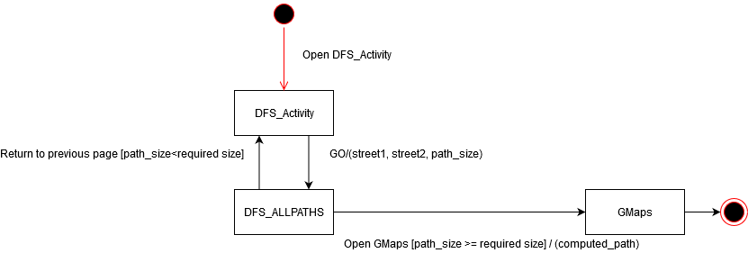

Fig 2.3: UML State Diagram for Dijkstra_Activity

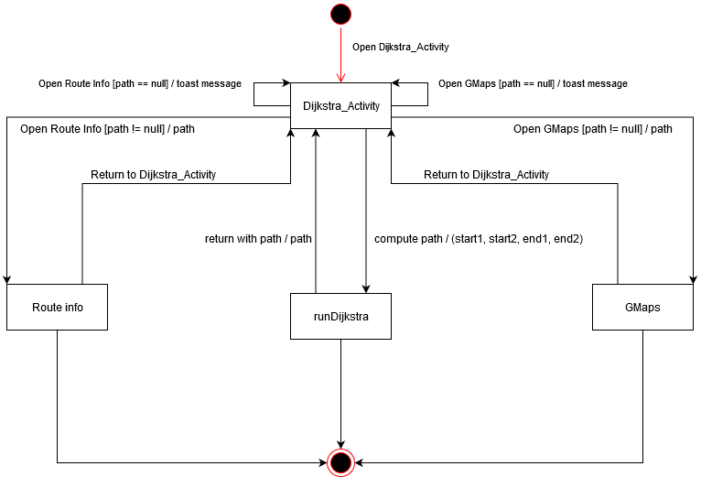

Review/Evaluation of Design

Overall, the application was designed well using the concepts of software qualities and modular design taught in the SE 2AA4 introductory software development. In addition, concepts of algorithmic practice/analysis taught in SE 2XB3 and 2C03 courses were effectively used for optimizing performance.

The development process was done in an agile manner rather than waterfall as it allows for rapid prototyping which contributes to the incremental approach in development. This way, anything that needs to be changed, can be done so in a manner that does not negatively impact the rest of the other stages of development. Different objectives of the project were assigned to different members of the team that all worked concurrently with version control software. This resulted in an overall smooth development process.

However, there were still some aspects that could have been improved upon in the development process. For instance, the background knowledge gathered on Google Maps API could have been researched more thoroughly during the planning stage. The team was aware of a few of the API limits but was not aware that only 25 intersections can be plotted on a route. This proved to be difficult as the Dijkstra algorithm can sometimes generate more than 25 intersections which results in the API to block the HTTP request.

To resolve this issue, every 5 or so intersections from the path were plotted rather than the entire path. This can lead to slightly inaccurate plotting as some intermediate intersections are missing. In the future, this could be changed so that different waypoint HTTP requests are called consecutively so that they can all be combined into one path at the end, without losing intermediate data.

Another issue was that of the accuracy in plotting the intersections in Google Maps. The intersections were formatted in the form street1@street2 rather than longitude and latitude coordinates. This was because some intersections from the dataset did not contain geographical coordinates. This resulted in the use of street names to pinpoint intersections. The negatives to this approach were that it all depended on how Google Maps interpreted the streets. Some streets may exist in other states of the U.S which resulted in Google Maps to incorrectly plot the intersections. For example Alabama St@Ripley St may exist in different states resulting in the API to plot incorrect start/end street.

To resolve this issue, the addition of the “San Francisco” keyword was added to the streets. So Alabama St and Ripley St became Alabama St,San Francisco and Ripley St,San Francisco. This somewhat resolved the problem of plotting streets in different states. However, it was also found that sometimes the streets plotted in San Francisco did not match that from the generated path. So something like Alabama St,San Francisco could end up being replaced by another street when GMaps begins plots. Again, this may have to do with how Google Maps interprets the data which is out of the teams control. For future revisions, it may be of benefit to gather location data in the form of longitude and latitude as it is a more accurate means of plotting.

Another issue was that of plotting Dijkstra’s algorithm. It was found at the end of the development process that the algorithm did not recognize some streets. This resulted in the program to completely ignore them when trying to compute the paths. This could have been due to inadequate testing on this module for the various streets as only a handful were tested. In addition, since this was also a top-down approach to development, it is another reason why lower level modules such as Dijkstra’s were not tested in-depth. In the future, it may be beneficial to spend more time on the testing stage before moving onto the actual integration and final development stages.

Aside from these few issues, the development process went relatively well. Although the testing phase could have been more rigorous for some modules, it still went relatively well for most. The use of Top-Down approach in incremental testing proved to be useful as it eliminated the idle time waiting for all modules to be complete. The time saved was used for other aspects of development such as module porting/integration for android studio.

In addition to this, the use of modular concepts such as high cohesion and low coupling were beneficial in modular design. It allowed each of the modules to be closely related without being completely dependent on each other. Having a good level of modularity proved to be useful as it isolated the concerns to separate modules. This way, bugs related to certain features can be traced back and debugged to their respective modules.

In the end, the mobile application was a success as it met the objectives and requirements from the SRS document while also making use of all three graph algorithms (BFS, DFS, Dijkstras) along with Search (BinarySearch) and sorting algorithms (QuickSort). It also included excellent software development principles(software qualities and testing) that proved to be useful. Time management and planning was well managed with multiple sprints to get the tasks done with minimal delay. Even though there were some problems along the way, the overall application works quite well and meets the design requirements.

References:

